Experiment 14:
Source code:
#include <reg51.h>
void main()
{
char message[] = "Hello World";
unsigned char i;
for(i = 0; message[i] != '\0'; i++)
{
P1 = message[i];
}
while(1);
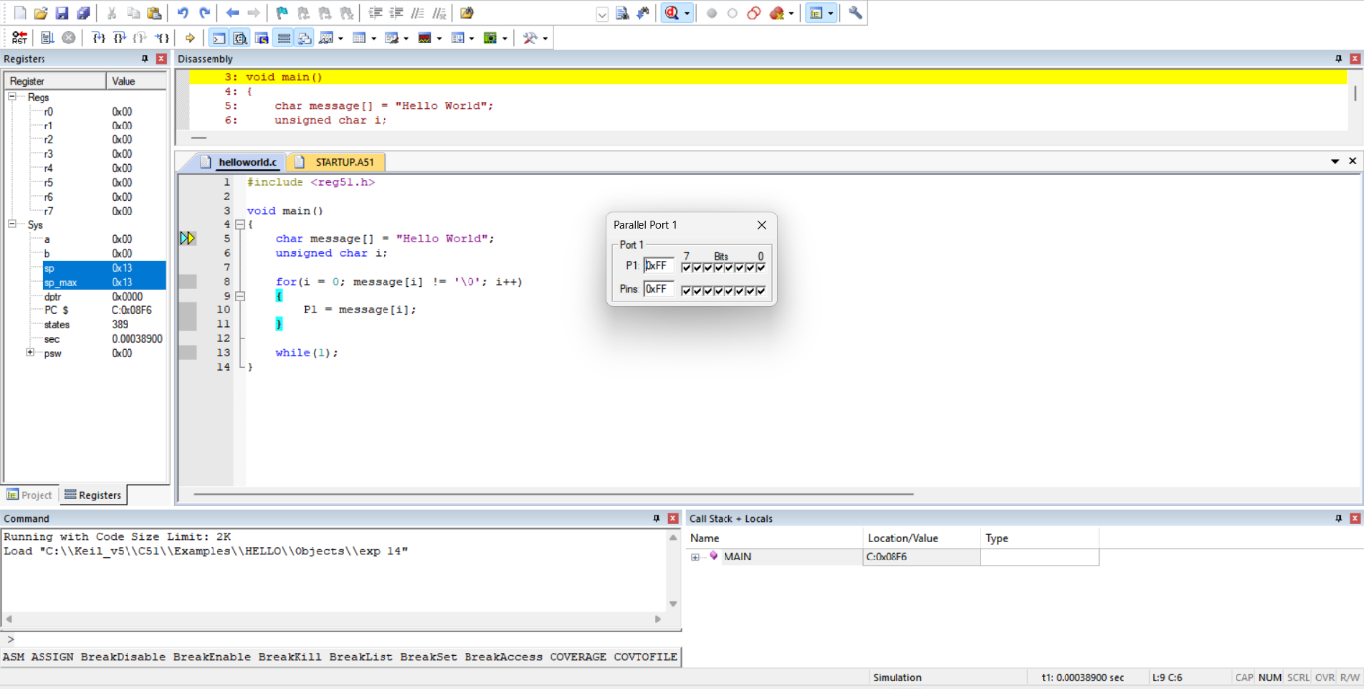
}

Output :

